**Advance Mathematics**

Lab 5

Yu-Hao Chiang 3443130

**Exercise 1 – Second order linear ODE’s with constant coefficients**

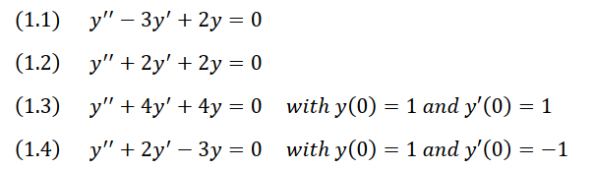

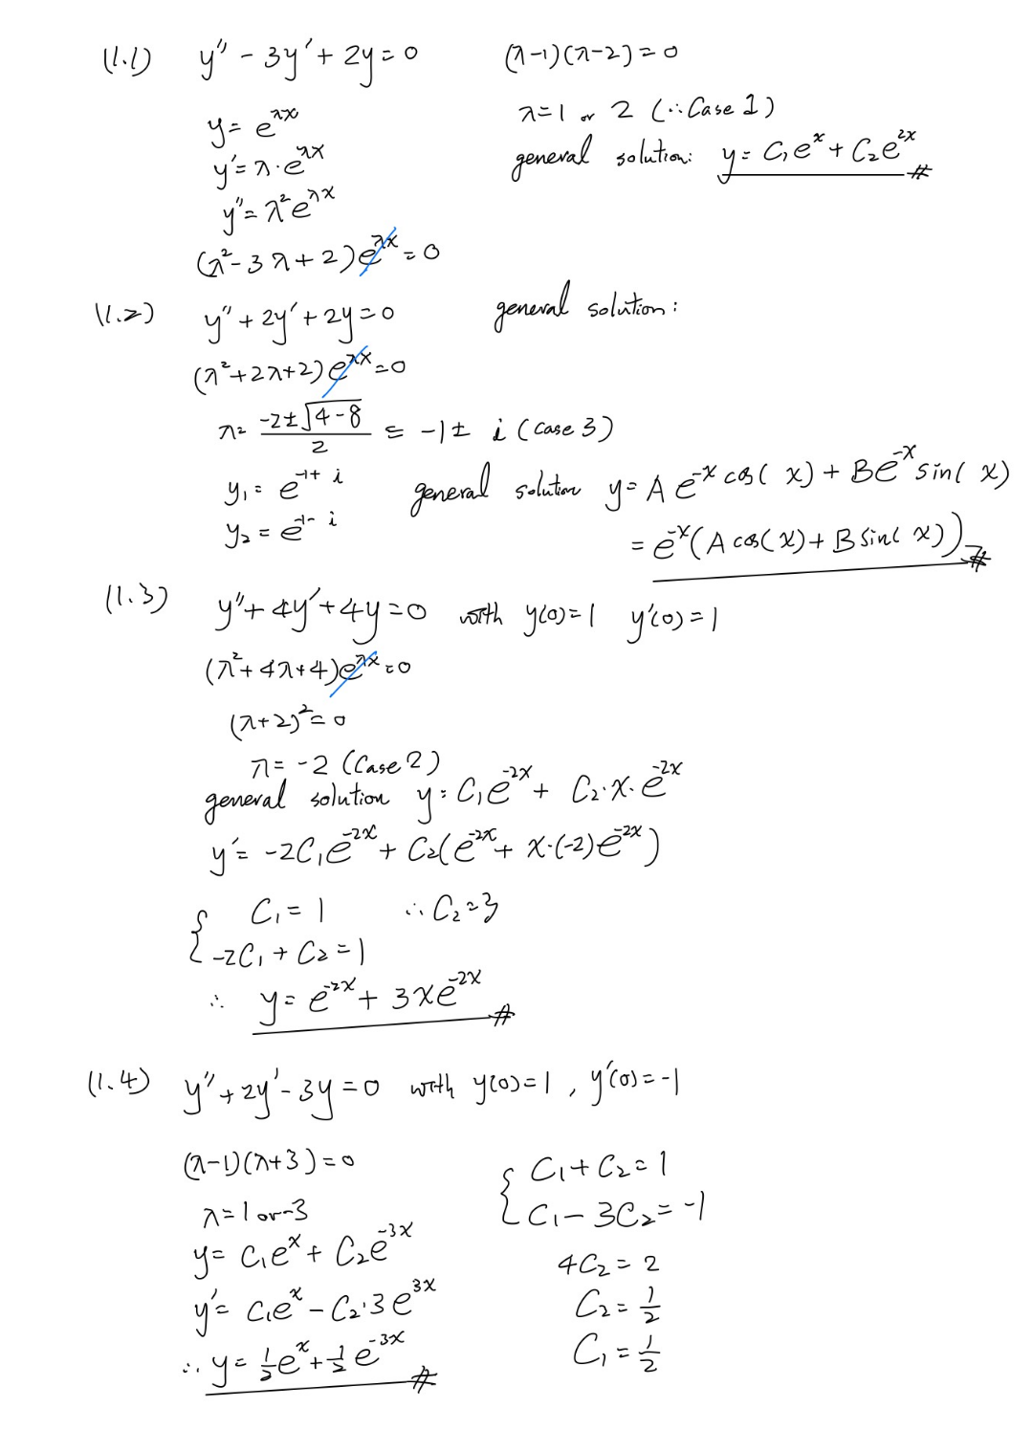

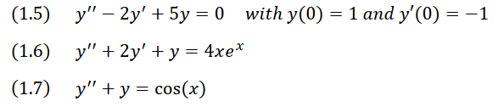

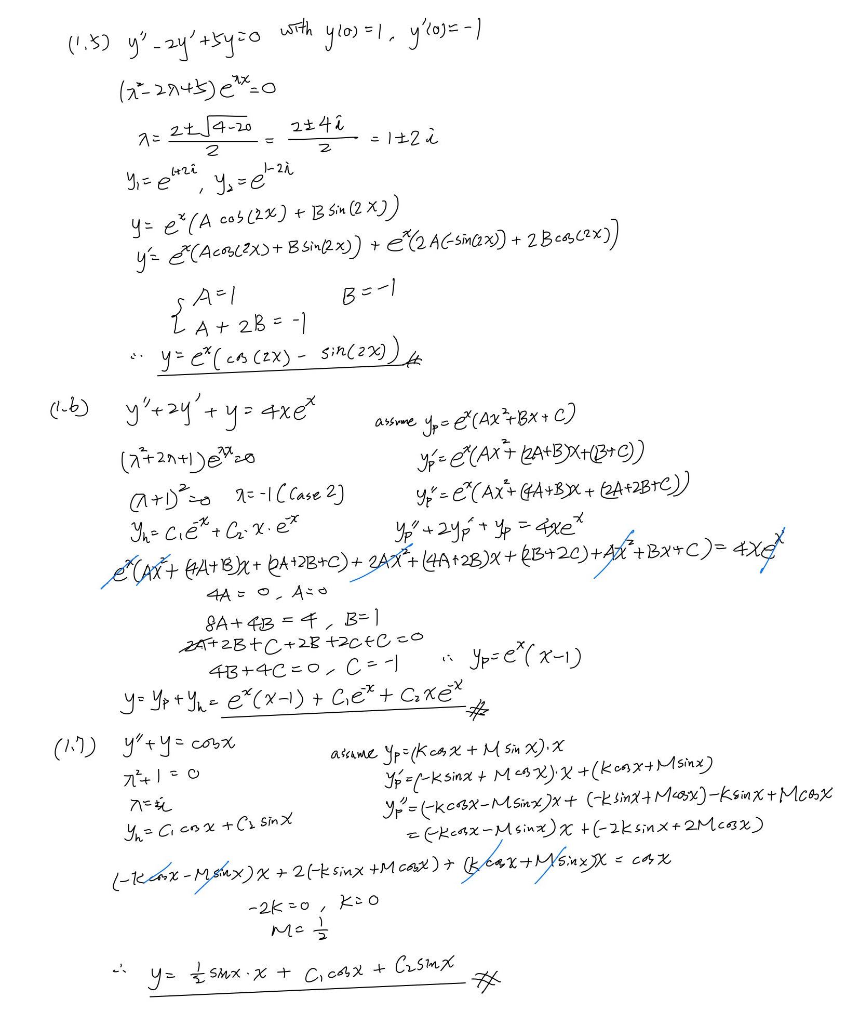



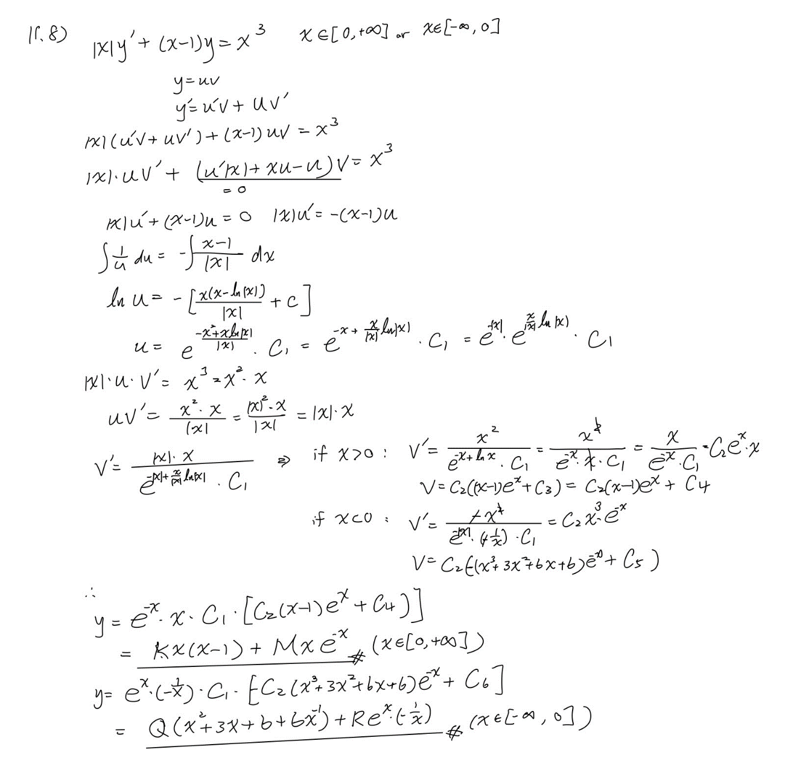

**Exercise 2 – Euler’s equidimensional equation**

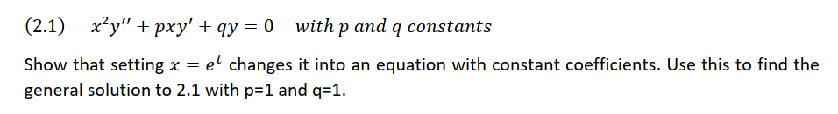

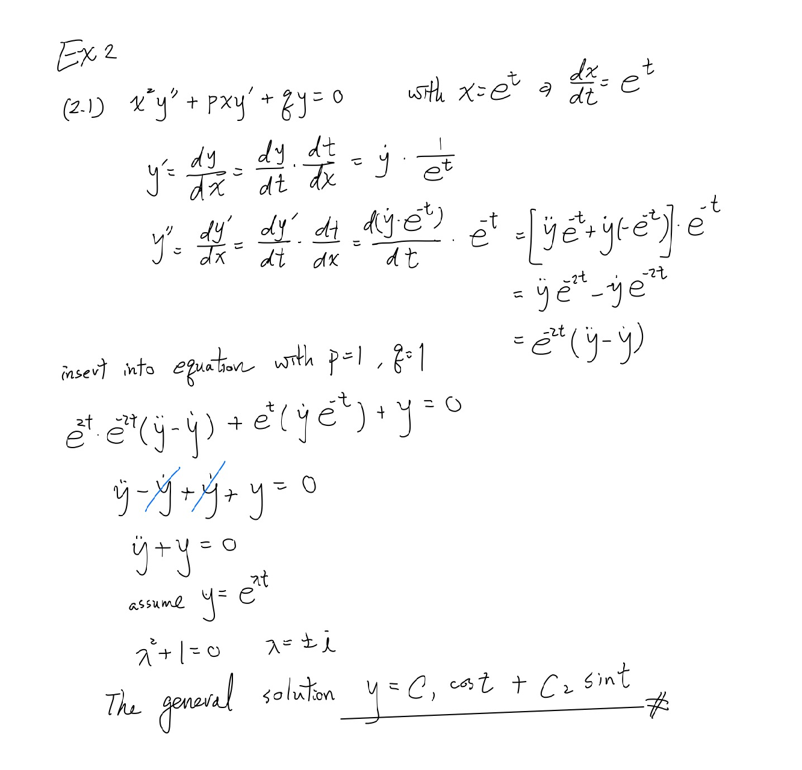

**Exercise 3 – Pendulum**

